Market Monitor - Burkina Faso - 2026-06

Highlights
Overview: Market conditions in Burkina Faso remain under severe pressure due to widespread food insecurity. High demand for staple foods, coupled with insufficient household income, continues to strain market affordability across the country, with many regions experiencing Crisis (IPC Phase 3) or Stressed (IPC Phase 2) outcomes.
Food Basket: The cost of the food basket was not available for June 2026.
Commodity Prices: Price data for key commodities was not available for June 2026.
Key Drivers:
- No quantitative data was available to determine specific market drivers for June 2026.
- Contextual reports indicate that market prices are primarily influenced by severe food security outcomes in several regions, widespread household income shortfalls, and a sustained, high-level need for humanitarian assistance.

Food basket cost trend

Market Overview
Market conditions across Burkina Faso in June 2026 are characterized by severe stress and upward pressure on the prices of essential foods. The primary driver is a widespread and deepening food security crisis, with large segments of the population lacking the purchasing power to meet their basic needs. Reports from May 2026 confirm that household income from key sources, such as artisanal mining and remittances, is insufficient to cover food purchases, indicating that market prices are prohibitively high relative to earnings. This affordability crisis is forcing households into severe food consumption gaps, particularly in the hardest-hit regions.
The situation is compounded by a sustained, high-level need for humanitarian assistance nationwide. While organizations like the World Food Programme (WFP) are providing critical support, operational constraints, such as those that led to a slight decrease in aid distribution in April 2026, highlight the fragility of the response. Any reduction in aid places immediate additional pressure on local markets, as households with depleted resources are forced to compete for limited and expensive food supplies. The outlook suggests a continued deterioration of market access for vulnerable populations, with prices expected to remain high or increase further as the lean season progresses.

Commodity Analysis
While quantitative price data for specific commodities was not available for this reporting period, qualitative food security indicators paint a clear picture of extreme unaffordability for staple foods. The prevalence of Crisis (IPC Phase 3) and Stressed (IPC Phase 2) food security outcomes across multiple regions is a direct reflection of the high cost of a basic food basket relative to household income. The core of the market crisis is not necessarily a nationwide absence of supply, but rather a critical failure of economic access.
Reports from May 2026 explicitly state that household incomes are inadequate to finance food purchases, meaning the market prices for staple grains like millet and sorghum, as well as other essential items, have risen beyond the reach of the poor and conflict-affected populations. This forces households to resort to negative coping strategies, such as reducing meal frequency and diversity, and increases their dependency on external aid. The fact that food assistance is essential for maintaining even minimal food consumption in regions like Djelgodji and Yagha underscores that the market is not functioning for the most vulnerable. Without a significant improvement in household purchasing power or a substantial increase in humanitarian assistance, the economic inaccessibility of staple foods will continue to drive the ongoing food security emergency.
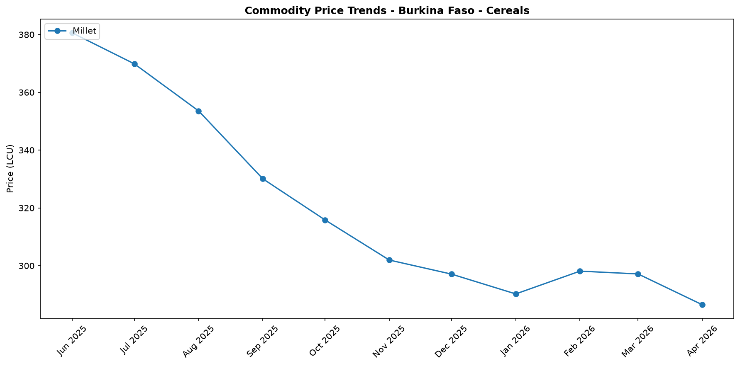
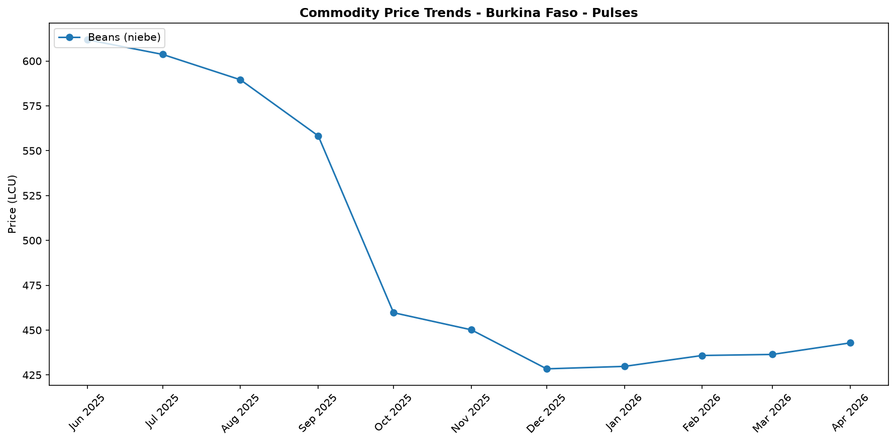

Regional Highlights
Significant regional disparities in market pressure are evident, directly correlating with the severity of localized food security crises. The situation is most dire in the Karo-Peli region, which was experiencing Crisis (IPC Phase 3) food security outcomes as of May 2026. This indicates that markets in the area are under extreme stress, with households facing significant food consumption gaps because their incomes are wholly insufficient to purchase basic foodstuffs at prevailing prices.
In contrast, the Djelgodji and Yagha regions are classified as Stressed (IPC Phase 2), a less severe but still precarious situation. Here, the critical role of food assistance is preventing a further deterioration, suggesting that underlying market conditions remain fragile. Despite the aid, households in these regions still report income shortfalls, highlighting that market access remains a significant challenge. This regional variance underscores how humanitarian aid is currently propping up consumption in some areas, while in others, like Karo-Peli, the gap between income and food costs has become a full-blown crisis.
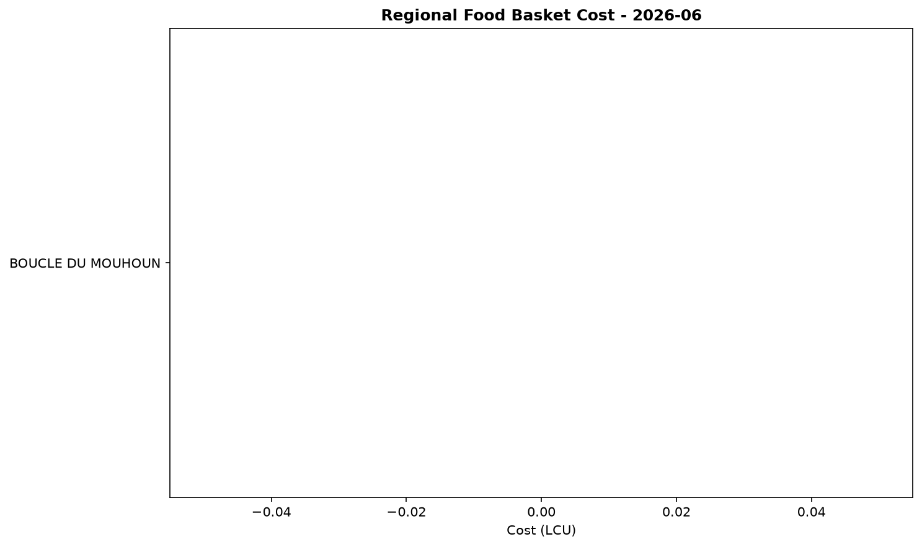

References
- [rw_4216245] ReliefWeb (2026-06-15) Concern reached 23 million people in 27 countries last year
https://reliefweb.int/node/4216245
- [rw_4215957] ReliefWeb (2026-06-11) Burkina Faso Key Message Update: Low incomes limit food access in the north of the country, May - September 2026
https://reliefweb.int/node/4215957
- [rw_4215834] ReliefWeb (2026-06-11) Regional Trends: Forced displacement in West and Central Africa - June 2026
https://reliefweb.int/node/4215834
- [rw_4214978] ReliefWeb (2026-06-05) WFP Burkina Faso Country Brief, May 2026
https://reliefweb.int/node/4214978
- [rw_4214617] ReliefWeb (2026-06-03) Annual Impact Report, January 2026
https://reliefweb.int/node/4214617
- [rw_4214537] ReliefWeb (2026-06-02) 24 million people in the Sahel urgently need aid and the world needs to do more
https://reliefweb.int/node/4214537
- [rw_4214524] ReliefWeb (2026-06-02) Sahel 2026 Humanitarian Needs & Requirements Overview (May 2026) [EN/FR]
https://reliefweb.int/node/4214524
- [rw_4212267] ReliefWeb (2026-05-15) Bi-monthly pastoral surveillance bulletin in the Sahel (N°37 / February-March 2026)
https://reliefweb.int/node/4212267
- [rw_4212067] ReliefWeb (2026-05-14) Sweden announces more than SEK 2.7 billion in humanitarian assistance to the world’s most vulnerable
https://reliefweb.int/node/4212067
- [rw_4210853] ReliefWeb (2026-05-06) Burkina Faso, Mali and Western Niger - Humanitarian Overview (As of 29 April 2026)
https://reliefweb.int/node/4210853
- [seerist_1028907] Seerist (2026-06-09) Political stability risk to remain EXTREME amid reports of tensions in security apparatus
- [seerist_1028814] Seerist (2026-06-03) Benin’s diplomatic push to re-activate security, trade cooperation with AES
- [seerist_1028760] Seerist (2026-05-29) Crackdown on opposition to intensify popular discontent, sustain political stability risks
- [seerist_1028721] Seerist (2026-05-27) Big Picture series: Carbon markets in Sub-Saharan Africa – growing opportunities amid regulatory, integrity challenges
- [seerist_1028607] Seerist (2026-05-19) Big Picture series: France’s push into anglophone Africa to bring new commercial opportunities despite West African controversies

